Smoke sensor Integration Overview
The integration of the MQ-135 smoke sensor into our cloud computing architecture utilized simulated sensors from MyDevices.com for the initial setup, with plans to deploy real sensors using ESP8266 microcontrollers in the final project phase. This simulation approach allows for testing and development without the need for physical hardware initially, streamlining the proof of concept and software development stages. The MQ-135 is particularly chosen for its ability to detect a variety of gases such as smoke, ammonia, and benzene, making it indispensable for comprehensive environmental monitoring. In the architecture, the simulated MQ-135 sensor data is transmitted via MQTT, a lightweight messaging protocol that facilitates efficient data communication between IoT devices and the cloud platform hosted on Node-RED.
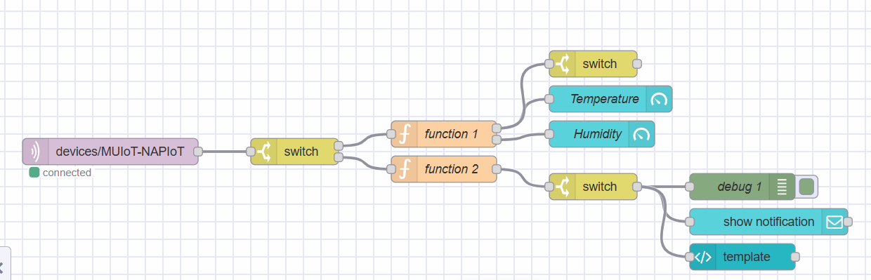

Data Processing and Visualization
Once the system transitions from simulated to real environments using ESP8266, the setup will maintain the integrity of data transmission using MQTT to Node-RED, where data processing and decision-making processes occur. The ESP8266 will be responsible for reading sensor outputs, converting them into a format suitable for analysis, and publishing them to the designated MQTT topics. Node-RED, configured on FlowFuse, will then subscribe to these topics, process the incoming data, and dynamically update the dashboard to reflect real-time environmental conditions. This real-time visualization is crucial for immediate response to potential hazards and for long-term environmental monitoring, ensuring that data-driven insights are accessible through a user-friendly interface on the dashboard, enhancing operational efficiency and safety.
